# 10 Reasons - Why Free Video Editing Softwares Are Bad

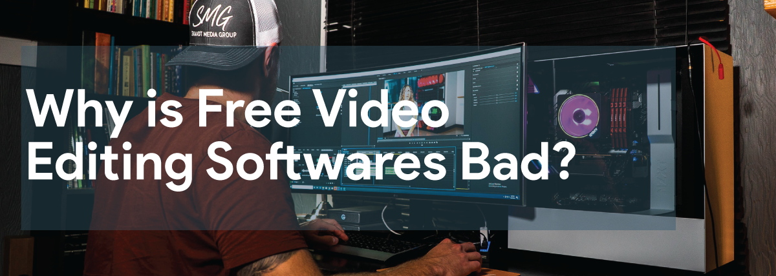

## What is video editing?

Video editing is basically joining small clips together, editing segments of motion videos, adding special effects and also adding sounds to it. It is basically operating video shots to create new video. Applying colours, giving titles, sound mixing and many other enhancements are considered as a post production process. There are many goals to edit video. It depends on the perspective of a situation and terminology. Before starting video editing you must define your goal like removing the unwanted footage and choosing the best footage, adding effects and graphics and many more. The process of creating relevant and unique content intended to change the behavior of your target audience over time is known as content marketing. When you achieve the goal via videos it is called video content marketing. The tool that you require for the same process and making the video attractive is known as video content marketing toolkit.

## Why free video editing softwares are bad:

Free video editing softwares is quite famous among digital camcorders but they are mostly considered bad. They are mostly used by the people who have less budget. They also have functions but they are not as good as the purchased ones.

So, here are 10 reasons which will notify you why free softwares is bad and you must always go for purchase once.

## Reasons Why Free Video Editing Software Are Bad:

### Safety issues:

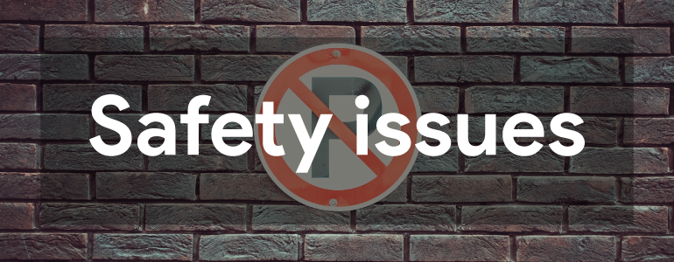

All the free video editing softwares that is available on the internet may contain viruses, malware, spyware or adware or worst case all of these. For making a software free there is trade in which these are to be added to the program. Many times while downloading a program, the terms and conditions specify or list the things to be downloaded and ensure you that they are harmless. But most of the times these downloads do not mention the additions.

### Lack of customer support:



We are taught from childhood that guests and customers are like god. In free video editing softwares or Video Creation Software it is a major concern they do not consider their [**CRM Strategy**](https://www.commino.co.uk/services/crm-strategy-and-planning/). The drawback of not having customer support to contact while facing a difficulty or having some kinds of questions could not be resolved. Stuck in midway while working is very irritating and frustrating. So it is better not to use such things that have a high risk of not getting work done.

### Extra Things:

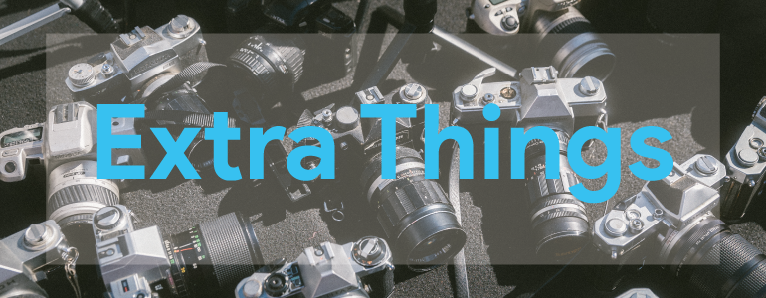

While downloading the free video editing software the program may automatically download some extras. These may be included even if you sometimes opt out or ticked them not to be included. These files may include things like screensavers, desktop themes, advertising software or any other kind of useless stuff. These add-ons or extras would have likely included trojans or viruses that can affect the computer’s performance greatly. So basically you should avoid using them for the best performance of your computer.

### Constant bugs and crashes:

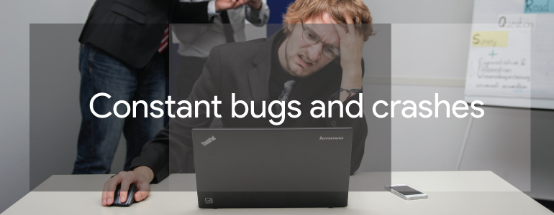

Many of the free video editing softwares are exposed to this problem. The user experiences many crashes and bugs while working on a video to edit. Not only that once the program is crashed you have to redo the whole work that you have been doing until now. It is a very time wasting process and also crashing again and again can make you quit the work. They also keep bringing new updates and new versions that make the computer more slow and less effective.

### Less price but less functions-



Free video editing softwaresis undeniably budget friendly. You don't need to spend money to edit your videos but with less price they have less functions. They barely have unique features. They don't provide good pixels for the edited video that's why the quality of new work is low. For normal purposes they are good but if you are really looking forward to going into the field of video editing then it is advisable to purchase the software. It will help you to learn editing properly. Even when you take a glimpse of the reviews of free video editing software you will only find the disappointment.

### No keyframe tracking-

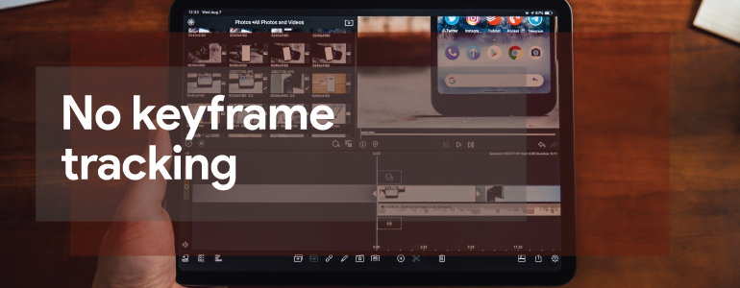

Keyframe tracking is fundamentally giving animation to objects. Keyframe tracking is the method that calculates tracks when placed in sequence. But free softwares do not have the ability of keyframe tracking and animating an object becomes a difficult task in it. If you want to create videos using keyframe then you must edit them in Premiere Pro. There are many hacks available in free softwares also but they are very difficult to use. It is quite challenging to give effects in free video editing softwares.

### Limited keyboard commands-

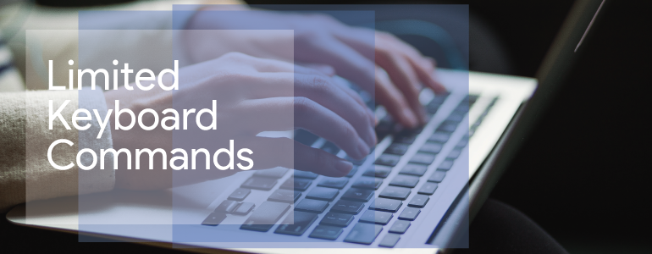

In free video editing softwares, you will notice that only limited keyboard commands are available. They are just basics. For advance work like clip slicing, changing clip speed you have to do a long process and sometimes in some videos do not give that facility also. It takes a lot of time and is quite hectic. They only provide keywords for save, play the video. So you must always go to purchase softwares for video editing.

### Export issues-



Mostly users complain about the exporting issues they experience during editing. This does not happen in all versions but mostly software do have this issue. Whenever the file is moving to the premiere pro it states that the file is encoded with unsupported format. Constant crashing and instability of software is the most common problem.

### Updating makes the computer more laggy:

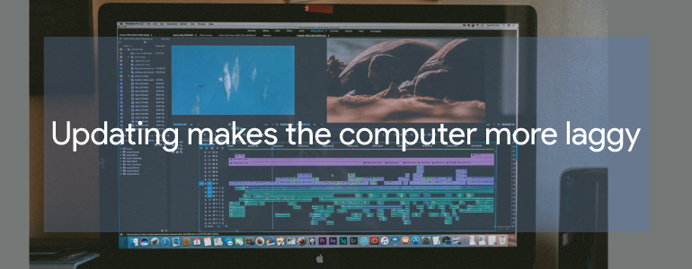

These free video editing software often requires you to update the software. Many times you have to update it like almost every once in a week. Some new features that they add do not seem to be particularly well designed or even tested. Converting the files to a required format is also not possible with these free video editing softwares and if it does it might add some virus to it.

### Some require premium:

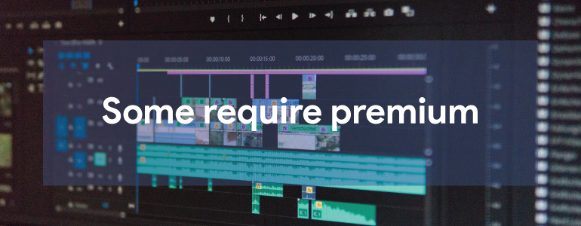

Even though they are free video editing softwares, at some point of time it may ask you to upgrade it for accessing the further tools. So basically you won’t be able to get the access of all the things on a free video editing software.

## Conclusion:

There are many different video editing programs and each of them is different . They all have different standards and also different kinds of usage. Even though free video editing software is sometimes a real pain.

**Meta Description**

Free videos editing is only beneficial for those who are not able to pay an amount. But if you want to grow then free video editing softwares is bad for you.

**Keywords**

Free Video Editing

Video Editing Softwares

**Author’s Bio**

**Name:** Gaurav Saraswat

**Designation:** SEO Executive

**Gravatar ID:** gaurav.technosoftwares12@gmail.com

**Social Media**: [Facebook](https://www.facebook.com/gaurav19991999) & [Linkedin](https://www.linkedin.com/in/gaurav-saraswat-3a0286169) & [Twitter](https://twitter.com/Gaurav41478131?s=09)



Myself Gaurav Saraswat and I serve as a Seo executive at one of the best [**Email Marketing Companies**](https://www.commino.co.uk/services/email-marketing-companies/) Techno Softwares. I’m a content writer as well. Feel free to ask anything related to SEO and Content Writing.